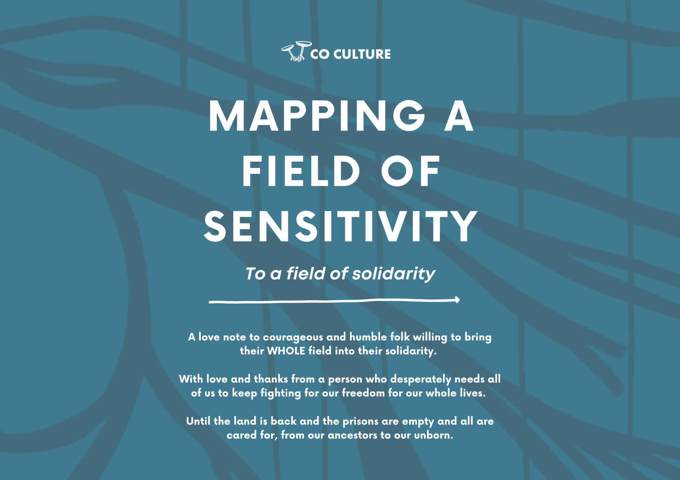

This is open sourcery.

Do this activity with friends, in community or in organising groups. Share your findings, generate new knowledge.. organise, make art, sing, create.. This is offered to communities of resistance. If you would like to use this resource for business or as part of training in organisations, please reach out at contact@coculturecommunication.com for permissions.

A NOTE ON REFERENCES

The reference list for this knowledge cannot be unstitched from the islands of Nanumaga, Vaitupu and Niutao in Tuvalua Tuvalu, in Te Moana Lasi - our Great Ocean, as well as Ireland and the unceded Kulin Lands I’ve been raised on as well as wisdom from nations and language groups across this continent.

The knowledge from my mentors and elders cannot be unstitched from the lands of the Yorta Yorta, Dja Dja Wurrung, Iñupiat, Sami, Scottish, Arrerrnte, Barakantiya and Halhal in the low lands of Eritrea and Tamil lands in Sri Lanka.

My children’s wisdom cannot be unstitched from Ngati Porou lands in Aotearoa, Shetland, Tonga and Nuer lands in South Sudan.

This body of work is also informed by Indigenous and resistance scholarship - both community-generated and within academia - from people and communities fighting for freedom across time.

This is offered with love from my/our lands and ancestors to you and yours.

Colonial imposition, annihilation and invasion has us believing that we are fragmented individuals, separated from ourselves, the land and from each other (Colonial Fragmentation Disorder). In reality, we are dynamic fields of stories, connections, memories, legacies, strength, love and possibility. This mapping exercise is a way to explore and experiment as we welcome our fragments home and integrate the many parts of ourselves that we marginalise and numb from, as the system has conditioned us to do.

When we integrate, connect and repair the relationships in and around us, we are resisting systems of oppression and separation.

Using the prompts on the following map, journal or reflect on the ways that trauma in your field might be stirred as you focus on and fight injustice. These prompts are only some areas of your field, you might notice other parts of yourself that are being stirred..include them too. Use the table below to note some of your reflections.

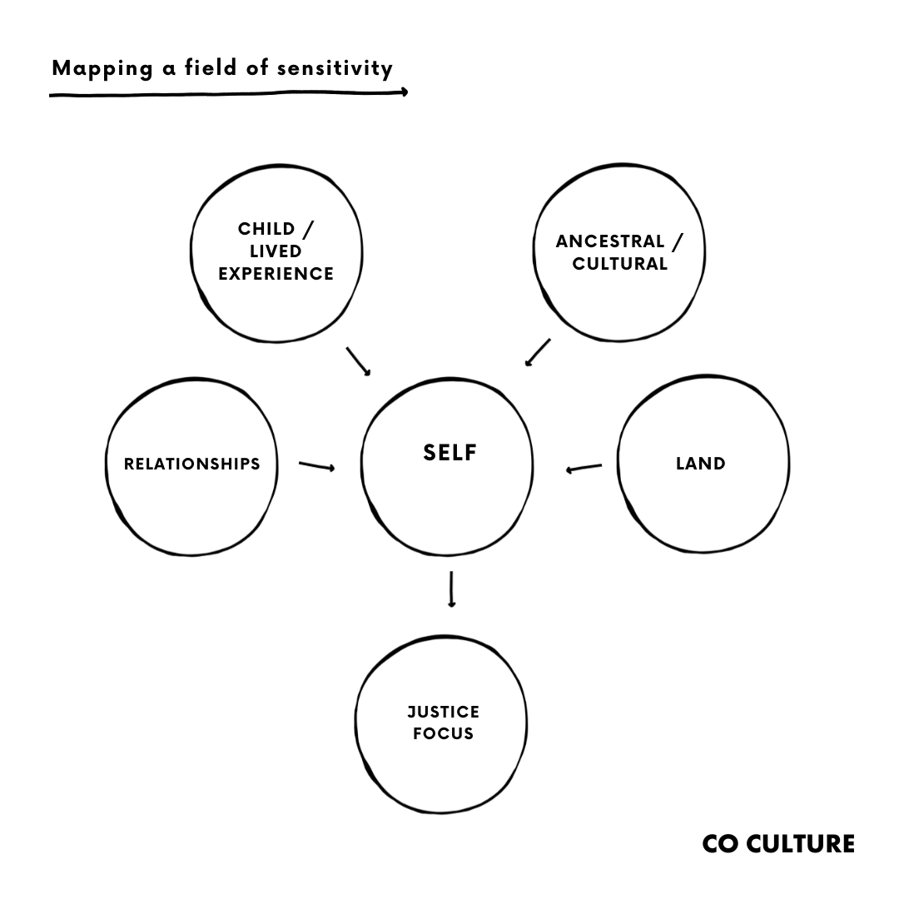

Be gentle with yourself, this is a heart and consciousness-opening process. Trust that you have worlds of untapped strength in your field. Colonial systems numb us from our whole experience because we become ungovernable when we heal, revere and inhabit our whole selves. To practice responsible resistance, you need to commit to the WHOLE process. In this case, if you can map your trauma, you MUST also map your strength in the second column.

Repeat the mapping activity and this time, using the second column, map strength, possibility and resistance in each area.

When you say F*CK THE SYSTEM, understand it is only half a prayer. What world do you want to build in it’s place?
Articulate your yearning.

NOTE: Many folks are currently focused on the genocide in Palestine and are experiencing the vicarious trauma of witnessing the annihilation of a people and an entire world. The justice focus can be anything you are fighting for. Any issue of injustice is likely to stir a similar experience of trauma recognition in your field.

Consider the following areas of self in your field that you might want to nurture your relationship with. | What trauma and distress is being stirred? | What strength, reverence and capacity is being awakened?
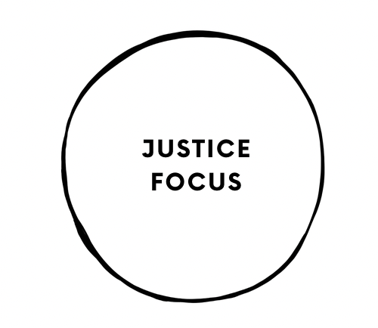 | Eg. Currently my justice focus is uplifting news and witnessing genocide in Palestine. I am experiencing vicarious trauma watching the violence as well as the gaslighting and denial and suppression of truth in the media. | Eg.I can remind myself that it is an honour to stand and fight with others. I can remind myself that I am ever changed by this witnessing and solidarity. That the quality and texture of the way I love and resist is forever changed. I am enriched when I bring my whole self into relationship with the stories, strengths and legacies in the fields of other people and allow myself to be transformed. Standing with any community is expanding my capacity for love.
 | ~ Your reflections here ~ | ~ Your reflections here ~
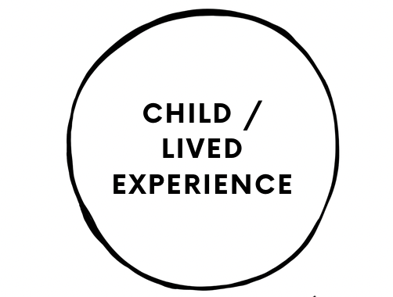 | Eg. My experiences of abuse, adult supremacy, marginalisation, systemic oppression of identity or community eg. disability, transness, queerness, ethnicity etc.. is being touched on in the following ways.. | Eg. I can believe and stand for my inner child and meet them with ferocious and reverent love. (Don't forget you also have an inner elder). I can listen to and make space for and heal and fight for every version of myself that has known abuse, domination and dehumanisation.
 | ~ Your reflections here ~ | ~ Your reflections here ~
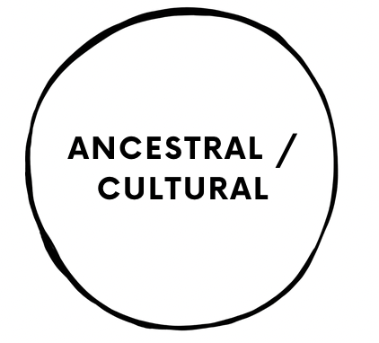 | Eg. I’m experiencing my lived and blood memories of dispossession, displacement, genocide & invasion. I’m also experiencing my lived and blood memory of the sacrifices of assimilation like suppression/shame of language and cultural practices. | Eg. I can pray for the strength of my ancestors who were survivors of annihilation. I can pray for the healing and repair of my ancestors who were active in invasion and colonisation. I can feel the pain my ancestors numbed from and fight for what they couldn’t (or wouldn’t). I can awaken the cultural practices and languages that my ancestors buried deep in my cells for protection in order to assimilate.
 | ~ Your reflections here ~ | ~ Your reflections here ~
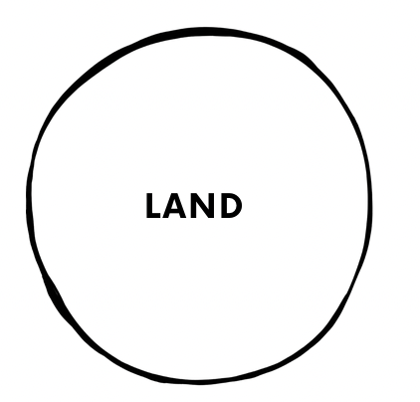 | Eg. I’m experiencing devastation at the loss of land and the suppression and annihilation of cultural practice for Tagata Fenua  (people of the land) here where I live. I’m experiencing devastation at the reminder that the unceded lands we live on have a memory and that I’m not in right-relationship with the place I call home. | Eg. I can bow my head to the land under my feet. I can learn the stories of love, culture and resistance that are stitched to the lands I live on and acknowledge that my story is also stitched to these lands. What would these lands say of me? What am I perpetuating here?  What am I resisting? I can privately and internally nurture a relationship of reverence with the ecosystem around me. I can begin repairing my relationship with the land under my feet by standing in solidarity with and learning from those who care for her intergenerationally. In settler colonies - Tagata Fenua, Indigenous people of the land. (If you are Tagata Fenua - you will likely already know what your lands need you to do.)
 | ~ Your reflections here ~ | ~ Your reflections here ~
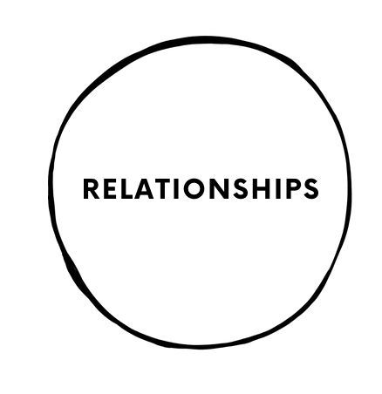 | Eg. I’m experiencing the pain in realising that some of my closest people enact their values in different ways to me which can feel like betrayal, abandonment and deception. | Eg. I can accept that not all people are on the same journey as me and that my energy and love is better spent nurturing the bonds I am forming through shared values and actions. I can practice enacting and articulating my values so that it’s easier for me to find my people. I can risk finding and nurturing community over and over again because no relational risk is so big that it should separate me from the people I am loved by but dont-yet-know and who I deserve to be with, in loving community.
 | ~ Your reflections here ~ | ~ Your reflections here ~

